

FINAL ENTERPRISE NETWORK TECHNICAL & PROJECT REPORT (WEEKS 1 - 8)

Course: Introduction to Networking (NWC204)
Class / Group: AS2102 | Group 04
Group Members: Nguyen Vo Gia Huy - SE205167
Duong Ba Trong - SE210504
Huynh Thien Ha - SE211279
Project Topic: Topic 2 – Regional Logistics & Warehousing Company
Assigned Base IP Block: 10.2.12.0/22 (Usable Range: 10.2.12.1 – 10.2.15.254, accommodating > 200 hosts)

I. ENTERPRISE OVERVIEW & SELECTED NETWORK ARCHITECTURE

1. Enterprise Overview
The Regional Logistics & Warehousing Company deploys a multi-site enterprise network infrastructure connecting two primary geographical locations:
- Main Head Office (HQ Site): Houses Executive Management, Finance & Accounting, and Customer Service departments.
- Warehouse Site (WH Site): Manages inventory control, operational logistics, security supervision, and a centralized server farm room.

2. Selected Network Topology Architecture & Technical Rationale
- Selected Network Model: Multi-Site Enterprise Network (Routed-Port Topology Architecture). The WAN topology utilizes a point-to-point Serial WAN link connecting HQ and Warehouse sites. Each department employs a dedicated Layer 2 Switch connected directly to an individual physical Router port (strictly adhering to the constraint forbidding VLANs or Layer 3 Switches).
- Technical Rationale:
  - Real-World Realism & Scalability: Accurately reflects actual logistics operations by isolating 7 distinct operational subnets optimized for VLSM subnetting.
  - Constraint Compliance: Solves the requirement for > 200 hosts using dedicated physical Router interfaces as mandated by project guidelines.

II. INFRASTRUCTURE EQUIPMENT INVENTORY

Device Type | Hostname | Quantity | Location / Department | Role & Description
Router | R1-Group04-HQ | 1 | Main Office (HQ) | Cisco 2911 (HWIC-2T), HQ Gateway
Router | R2-Group04-WH | 1 | Warehouse Site (WH) | Cisco 2911 (HWIC-2T), Warehouse Gateway 1
Router | R3-Group04-WH | 1 | Warehouse Site (WH) | Cisco 2911, Internal WH & Server Room Gateway
L2 Switch | SW-EXEC, SW-FIN, SW-CS | 3 | HQ (3 Departments) | Dedicated Cisco Catalyst 2960 Switches
L2 Switch | SW-INV, SW-LOG, SW-SEC, SW-IT | 4 | Warehouse (4 Subnets) | Dedicated Cisco Catalyst 2960 Switches
Workstation | PC0 to PC15 | 14 | Distributed Subnets | Representative testing endpoints
Server | DHCP, DNS, HTTP, Mail | 4 | Server Room (WH) | Centralized 4 Core Network Services

III. VLSM IP ADDRESSING TABLE (Base Network Block: 10.2.12.0/22)
- IP ADDRESSING TABLE
Area / Router | Department / Link | Hosts | Network ID | Subnet Mask | IP Gateway | Usable IP Range / Server IP
R1-HQ | Executive Mgmt (EXEC) | 10 | 10.2.12.0/28 | 255.255.255.240 | 10.2.12.1 | 10.2.12.2 – 10.2.12.14
R1-HQ | Finance (FIN) | 30 | 10.2.12.16/27 | 255.255.255.224 | 10.2.12.17 | 10.2.12.18 – 10.2.12.46
R1-HQ | Customer Service (CS) | 30 | 10.2.12.64/27 | 255.255.255.224 | 10.2.12.65 | 10.2.12.66 – 10.2.12.94
R2-WH | Inventory Control (INV) | 100 | 10.2.12.128/25 | 255.255.255.128 | 10.2.12.129 | 10.2.12.130 – 10.2.12.254
R2-WH | Logistics Operations (LOG) | 50 | 10.2.13.0/26 | 255.255.255.192 | 10.2.13.1 | 10.2.13.2 – 10.2.13.62
R2-WH / R3-WH | Inter-Router Link (R2-R3) | 2 | 10.2.13.96/30 | 255.255.255.252 | 10.2.13.97 | 10.2.13.98
R3-WH | Security Subnet (SEC) | 10 | 10.2.13.64/28 | 255.255.255.240 | 10.2.13.65 | 10.2.13.66 – 10.2.13.78
R3-WH | IT / Server Room (IT) | 14 | 10.2.13.80/28 | 255.255.255.240 | 10.2.13.81 | 10.2.13.82 – 10.2.13.94
R1-HQ / R2-WH | Serial WAN (HQ-WH) | 2 | 10.2.15.252/30 | 255.255.255.252 | 10.2.15.253 | 10.2.15.254

Khu vực 1: Trụ sở chính (Main Head Office - R1-HQ)

IP Server DNS được gán cho các PC: 10.2.13.85

Tên Máy trạm | Khu vực / Phòng ban | Địa chỉ IP khả dụng | Subnet Mask | Default Gateway | DNS Server IP
PC2 | Finance (FIN) | 10.2.12.2 | 255.255.255.224 | 10.2.12.1 | 10.2.13.85
PC3 | Finance (FIN) | 10.2.12.3 | 255.255.255.224 | 10.2.12.1 | 10.2.13.85
PC0 | Executive Mgmt (EXEC) | 10.2.12.34 | 255.255.255.240 | 10.2.12.33 | 10.2.13.85
PC1 | Executive Mgmt (EXEC) | 10.2.12.35 | 255.255.255.240 | 10.2.12.33 | 10.2.13.85
PC4 | Customer Service (CS) | 10.2.12.66 | 255.255.255.224 | 10.2.12.65 | 10.2.13.85
PC15 | Customer Service (CS) | 10.2.12.67 | 255.255.255.224 | 10.2.12.65 | 10.2.13.85

Khu vực 2: Nhà kho & Vận hành (Warehouse Site - R2-WH & R3-WH)

Tên Máy trạm | Router | Phòng ban / Subnet | Địa chỉ IP khả dụng | Subnet Mask | Default Gateway | DNS Server IP
PC7 | R2-WH | Inventory Control (INV) | 10.2.12.130 | 255.255.255.128 | 10.2.12.129 | 10.2.13.85
PC8 | R2-WH | Inventory Control (INV) | 10.2.12.131 | 255.255.255.128 | 10.2.12.129 | 10.2.13.85
PC9 | R2-WH | Logistics Ops (LOG) | 10.2.13.2 | 255.255.255.192 | 10.2.13.1 | 10.2.13.85
PC10 | R2-WH | Logistics Ops (LOG) | 10.2.13.3 | 255.255.255.192 | 10.2.13.1 | 10.2.13.85
PC11 | R3-WH | Security Subnet (SEC) | 10.2.13.66 | 255.255.255.240 | 10.2.13.65 | 10.2.13.85
PC12 | R3-WH | Security Subnet (SEC) | 10.2.13.67 | 255.255.255.240 | 10.2.13.65 | 10.2.13.85
PC13 | R3-WH | IT / Server Room (IT) | 10.2.13.82 | 255.255.255.240 | 10.2.13.81 | 10.2.13.85
PC14 | R3-WH | IT / Server Room (IT) | 10.2.13.83 | 255.255.255.240 | 10.2.13.81 | 10.2.13.85

QUY HOẠCH IP CỐ ĐỊNH CHO CÁC SERVERS (STATIC IP)

Vị trí: Phân mạng IT / Server Room (10.2.13.80/28) tại R3-WH

Subnet Mask: 255.255.255.240

Default Gateway: 10.2.13.81
Tên Server | Loại dịch vụ | Tên miền / Ghi chú | Địa chỉ IP Tĩnh (Static IP) | Subnet Mask | Default Gateway
DHCP-Server | Centralized DHCP | Cấp IP động cho các Subnet | 10.2.13.84 | 255.255.255.240 | 10.2.13.81
DNS-Server | Domain Resolution | Resolution cho logistics-group04.com | 10.2.13.85 | 255.255.255.240 | 10.2.13.81
HTTP-Server | Web Intranet | Trang chủ [http://logistics-group04.com](http://logistics-group04.com) | 10.2.13.86 | 255.255.255.240 | 10.2.13.81
Mail-Server | Internal Email | Domain Mail @group04.com | 10.2.13.87 | 255.255.255.240 | 10.2.13.81

- Network Topology Diagram
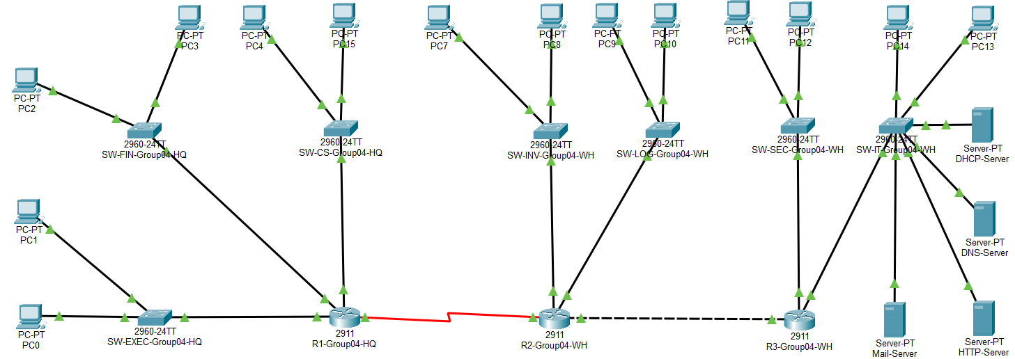

- Testing IP ping to other devices
During Weeks 1–4, static IP configurations were applied to all client workstations to perform baseline verification:
Case 1: Direct LAN Gateway Verification (HQ Site)
- Source Endpoint: PC0 (Executive Mgmt - Static IP: 10.2.12.2)
- Command: ping 10.2.12.1
- Target: Default Gateway of Executive Mgmt Subnet (R1-HQ GigabitEthernet0/0/0)
- Result: Reply from 10.2.12.1: bytes=32 time<1ms TTL=255 (100% Success)
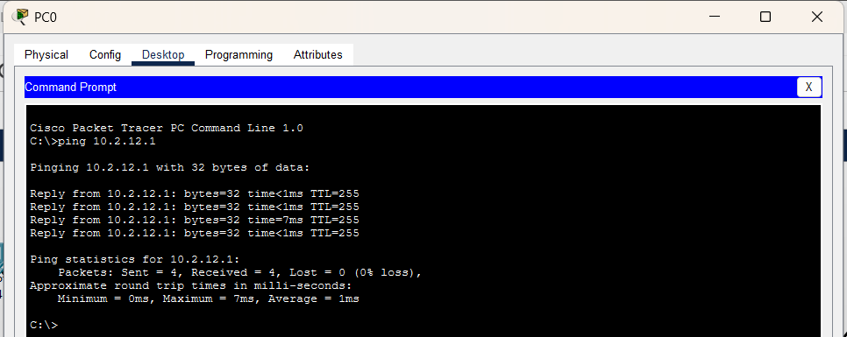
Case 2: Point-to-Point Serial WAN Verification (HQ to WH)
- Source Endpoint: PC0 (Executive Mgmt - Static IP: 10.2.12.2)
- Command: ping 10.2.15.254
- Target: Remote Serial WAN Interface of Warehouse Router (R2-WH Serial0/0/0)
- Result: Reply from 10.2.15.254: bytes=32 time=2ms TTL=254 (100% Success)
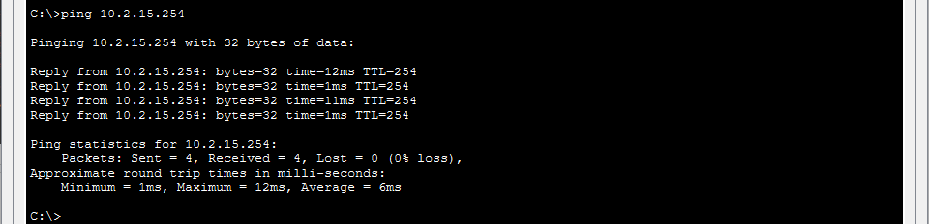
Case 3: Inter-Site Cross-Regional LAN Verification (HQ to WH Remote Gateway)
- Source Endpoint: PC0 (Executive Mgmt - Static IP: 10.2.12.2)
- Command: ping 10.2.13.81
- Target: Default Gateway of IT / Server Room Subnet (R3-WH GigabitEthernet0/0/2)
- Result: Reply from 10.2.13.81: bytes=32 time=3ms TTL=254 (0% Loss)
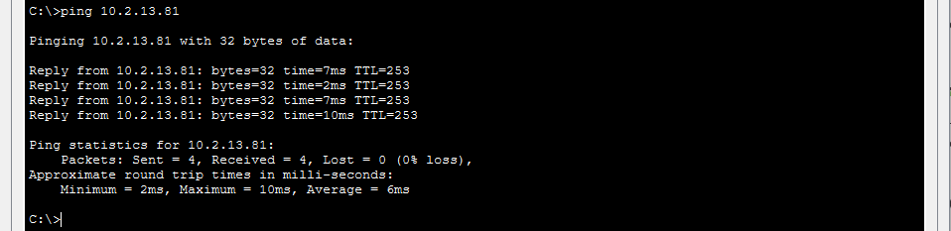

IV. CORE SERVICES DEPLOYMENT & MIGRATION TO DYNAMIC DHCP

1. Transition from Static IP to Dynamic DHCP Allocation
- Weeks 1–4 (Implementation Phase): Workstations were assigned Static IP addresses to perform interface routing checks and baseline WAN verification as detailed in Section 3.3.
- Weeks 5–8 (Services Phase): The network migrated from Static IP settings to Dynamic IP Allocation via DHCP. Workstations were toggled from Static to DHCP mode to dynamically fetch network parameters from the centralized DHCP Server (10.2.13.84) located in the Warehouse Server Room. To enable cross-subnet dynamic addressing, ip helper-address 10.2.13.84 was configured on all Router interfaces acting as local Default Gateways.

2. Centralized Core Services Configuration
All core servers reside statically within the Server Room subnet (10.2.13.80/28):
- DHCP Server (10.2.13.84): Central DHCP service managing dedicated address pools mapped to respective departmental subnets, default gateways, and DNS settings.
- DNS Server (10.2.13.85): Internal domain name resolution mapping logistics-group04.com to the HTTP Web Server IP 10.2.13.86.
- HTTP Web Server (10.2.13.86): Corporate Intranet portal for cargo tracking and internal warehouse administration.
- Email Server (10.2.13.87): SMTP/POP3 mail service under domain group04.com with user accounts configured for administrative and operational staff.

V. BASELINE HARDENING & ADVANCED SECURITY
- Baseline Security Hardening (Applied across 3 Routers & 7 Switches):
  - Minimum password length requirement: security passwords min-length 10.
  - Encrypted EXEC Secret Password: enable secret Class12345!.
  - Global plain-text password encryption: service password-encryption.
  - Console & VTY line access protection secured with password Group4Pass!.
  - Enforced SSH v2 and disabled insecure Telnet access (transport input ssh).
  - Brute-force protection: login block-for 120 attempts 3 within 30.
  - Executive session idle timeout: exec-timeout 5 0.
  - Unused physical interfaces explicitly shut down (shutdown).
- Advanced Security Controls (Access Control Lists - ACLs):
  - Extended ACL: Configured on R3-WH to block the Security/Surveillance subnet (10.2.13.64/28) from reaching the Server Room (10.2.13.80/28).
  - Standard ACL: Configured on R1-HQ restricting SSH remote access solely to authorized IT management hosts (10.2.13.82).

VI. END-TO-END SYSTEM TESTING & VERIFICATION (TESTING WHEN DHCP IS ENABLED)
System verification conducted after activating the central DHCP Server and DHCP Relay Agents:
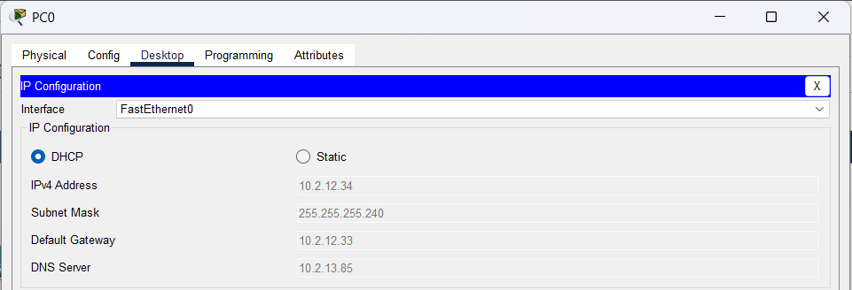
- Dynamic IP Assignment Verification: Workstations switched from Static to DHCP mode successfully received dynamic IP configurations showing DHCP request successful with proper IP, Subnet Mask, Gateway, and DNS settings.

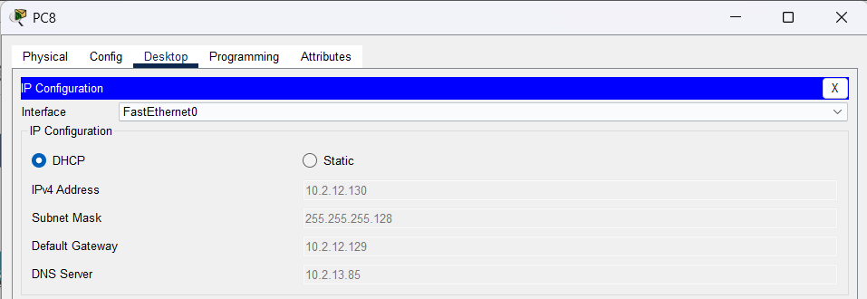
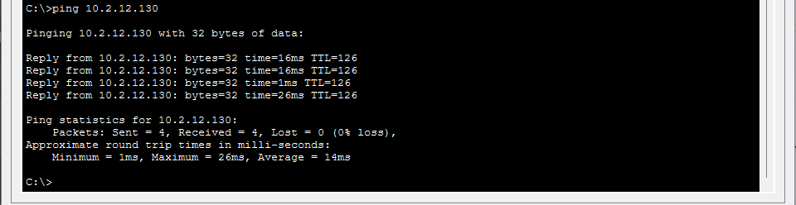
- Intranet Web Testing: Web browser access from PC2 (Finance - HQ) to [http://logistics-group04.com](http://logistics-group04.com) rendered the internal portal homepage successfully.
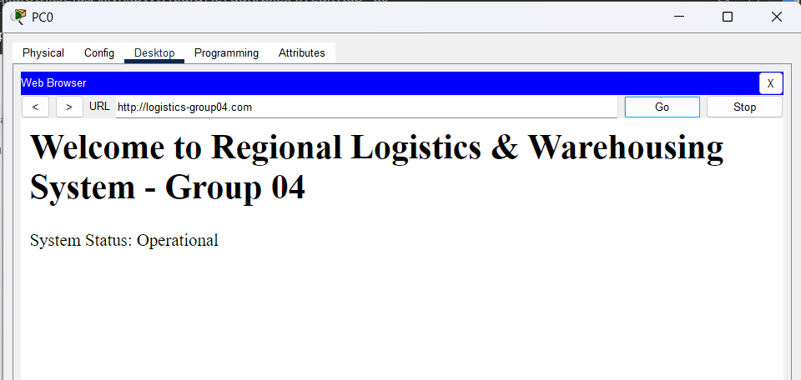

- Email Connectivity Verification: Transmitting mail from giamdoc@group04.com on PC0 to ketoan@group04.com on PC2 completed with Send Success status.
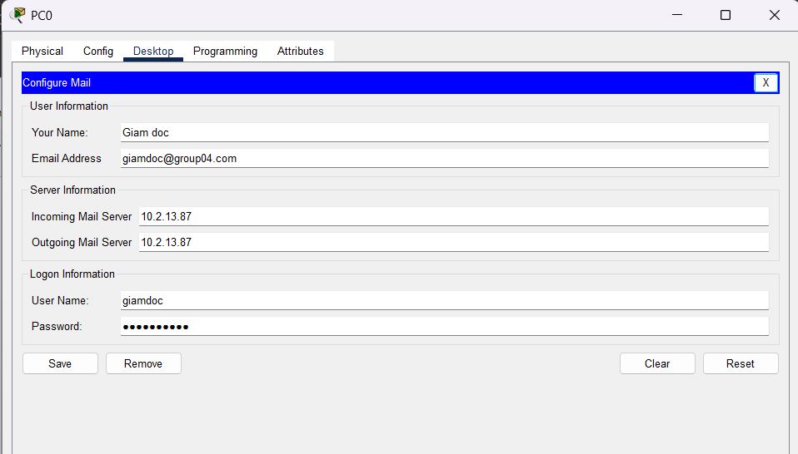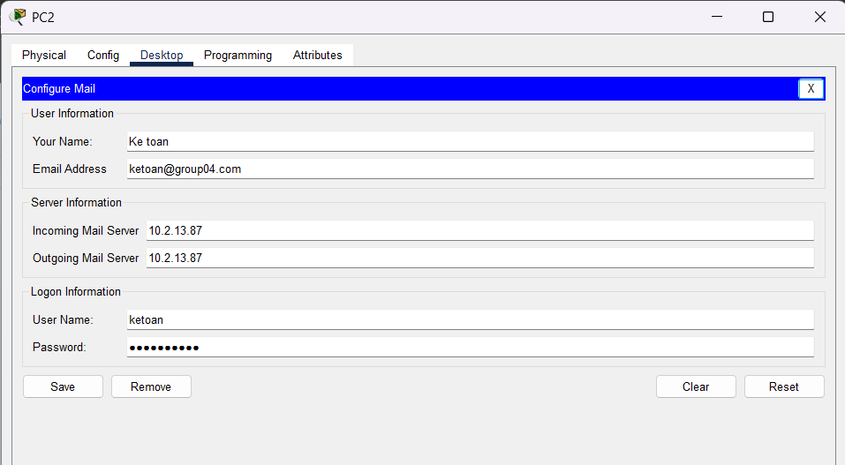
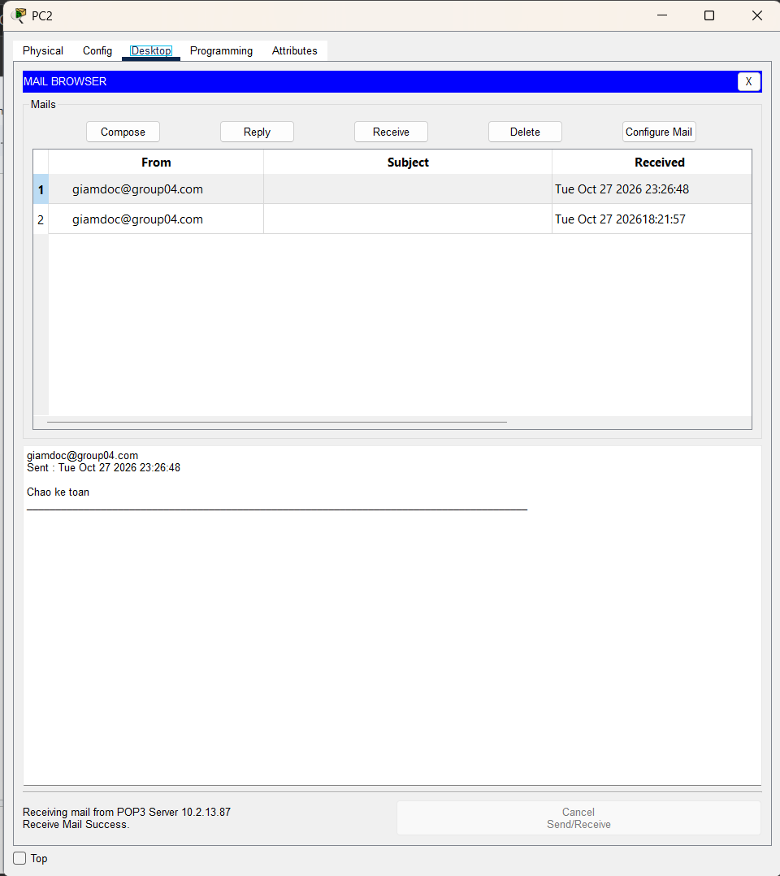
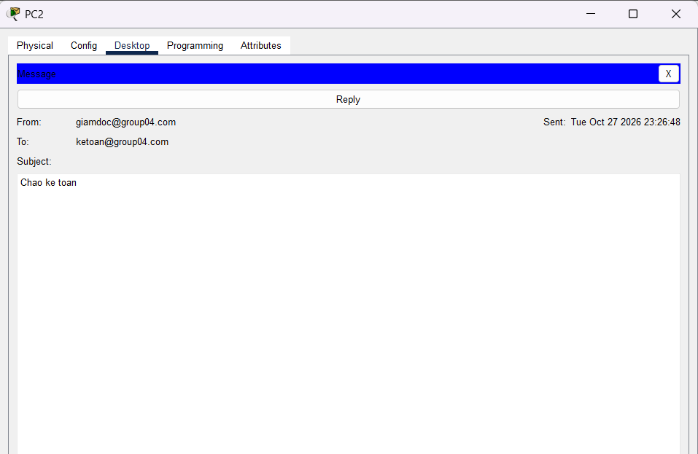
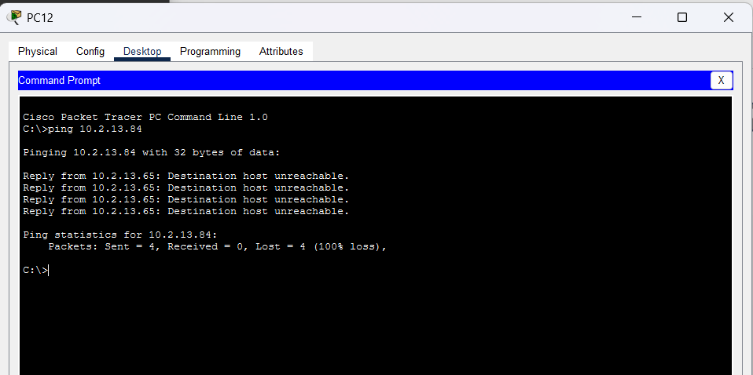
- ACL Security Verification: Ping requests from the Security subnet to Server IPs were denied (Destination Host Unreachable), while cross-site ICMP traffic from authorized subnets remained fully functional.

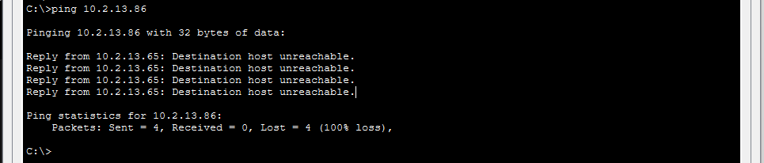

VII. PROJECT SUMMARY & CONCLUSION (WEEK 8)
The enterprise network design and implementation project for Group 04 - Regional Logistics & Warehousing Company has achieved 100% of its planned deliverables:
- Fully complies with all strict technical constraints imposed by the course guidelines.
- Efficiently accommodates > 200 users using an optimized VLSM subnetting plan.
- Successfully transitioned network hosts from initial static configurations to dynamic DHCP allocation supported by centralized core services.
- Fully validated Packet Tracer .pkt file, comprehensive documentation, and presentation materials prepared for the final project defense.

